Project Proposal Form, 2025
Institute of Information Technology (IIT)
University of Dhaka

Student’s Name: | Md. Asad Al Mahmud  Tarek Jamil Adnan
Student’s Roll: | BSSE 1515  BSSE 1520 | Phone: | +8801721290790  +8801642477845
Project Title: BanRAP: A Road Labeling, Star Rating, and Safety-Aware Navigation System
Motivation:Bangladesh suffers from a lack of organized and reliable road safety data. While platforms like Google Maps provide traffic and travel information, they do not reflect the actual safety or physical condition of roads. As a result, road users and authorities cannot make informed decisions. This project aims to develop a system similar to iRAP (International Road Assessment Programme), tailored for Bangladesh, which will assess road safety and condition through labeling and star rating. The system will also integrate these safety metrics into a navigation module that adjusts travel time according to road quality. This project will create a strong local impact by promoting data-driven road safety analysis and global relevance through alignment with international safety assessment standards.

Project Description: BanRAP (Bangladesh Road Assessment Program) is a web-based platform for analyzing and rating the safety condition of Bangladeshi roads. The system will allow analysts to select roads using Google Maps coordinates, automatically divide the selected road into 100-meter sections, and label each section using both 2D and 3D map interfaces, including Street View integration.
Each section will store labeling information such as lane width, roadside hazard, lighting, pedestrian safety, and vehicle mix. These labels will be processed through a rating algorithm inspired by iRAP, assigning 1 to 5 stars to indicate the road’s safety level. Users will be able to view ratings, and a navigation system will be introduced where travel time is adjusted according to the star ratings of the route , poor-rated roads will increase estimated travel time.
Registered users can view star-rated roads, use safety-aware navigation, and submit complaints or suggestions if they find labeling inaccurate. This ensures community participation and continuous improvement of the road safety database.

Key Features:
- Road selection from interactive map:
Enables users to visually select specific road sections directly from the map interface for analysis.
- Automatic 100-meter segmentation of selected road sections:
Divides each selected road into uniform 100-meter segments for detailed labeling and assessment.
- Integration of Google Maps APIs (2D, 3D, and Street View):
Provides real-world visualization and context through integrated 2D, 3D, and Street View maps.
- Map-based labeling interface:
Allows analysts to label road segments interactively using on-screen map tools and buttons.
- Star rating algorithm following iRAP logic:
Generates safety ratings (1–5 stars) for road segments based on iRAP-inspired parameters.
- User registration and login system:
Provides secure access for users, analysts, and administrators through account-based login.
- Admin and analyst dashboards for management and analysis:
Offers centralized control panels for managing data, users, and system feedback.

Exciting Features:
- Safety-aware navigation adjusting ETA based on road rating:
Enhances navigation by dynamically adjusting travel time based on road safety conditions.
- Feedback and complaint module:
Engages users by allowing them to report labeling issues or suggest corrections, fostering community participation.

Strategy & Timeline:
The project will follow an incremental development strategy, starting from basic road mapping to full system integration. Each module will be developed, tested, and refined over a structured 12-week timeline to ensure stability and feature completeness.

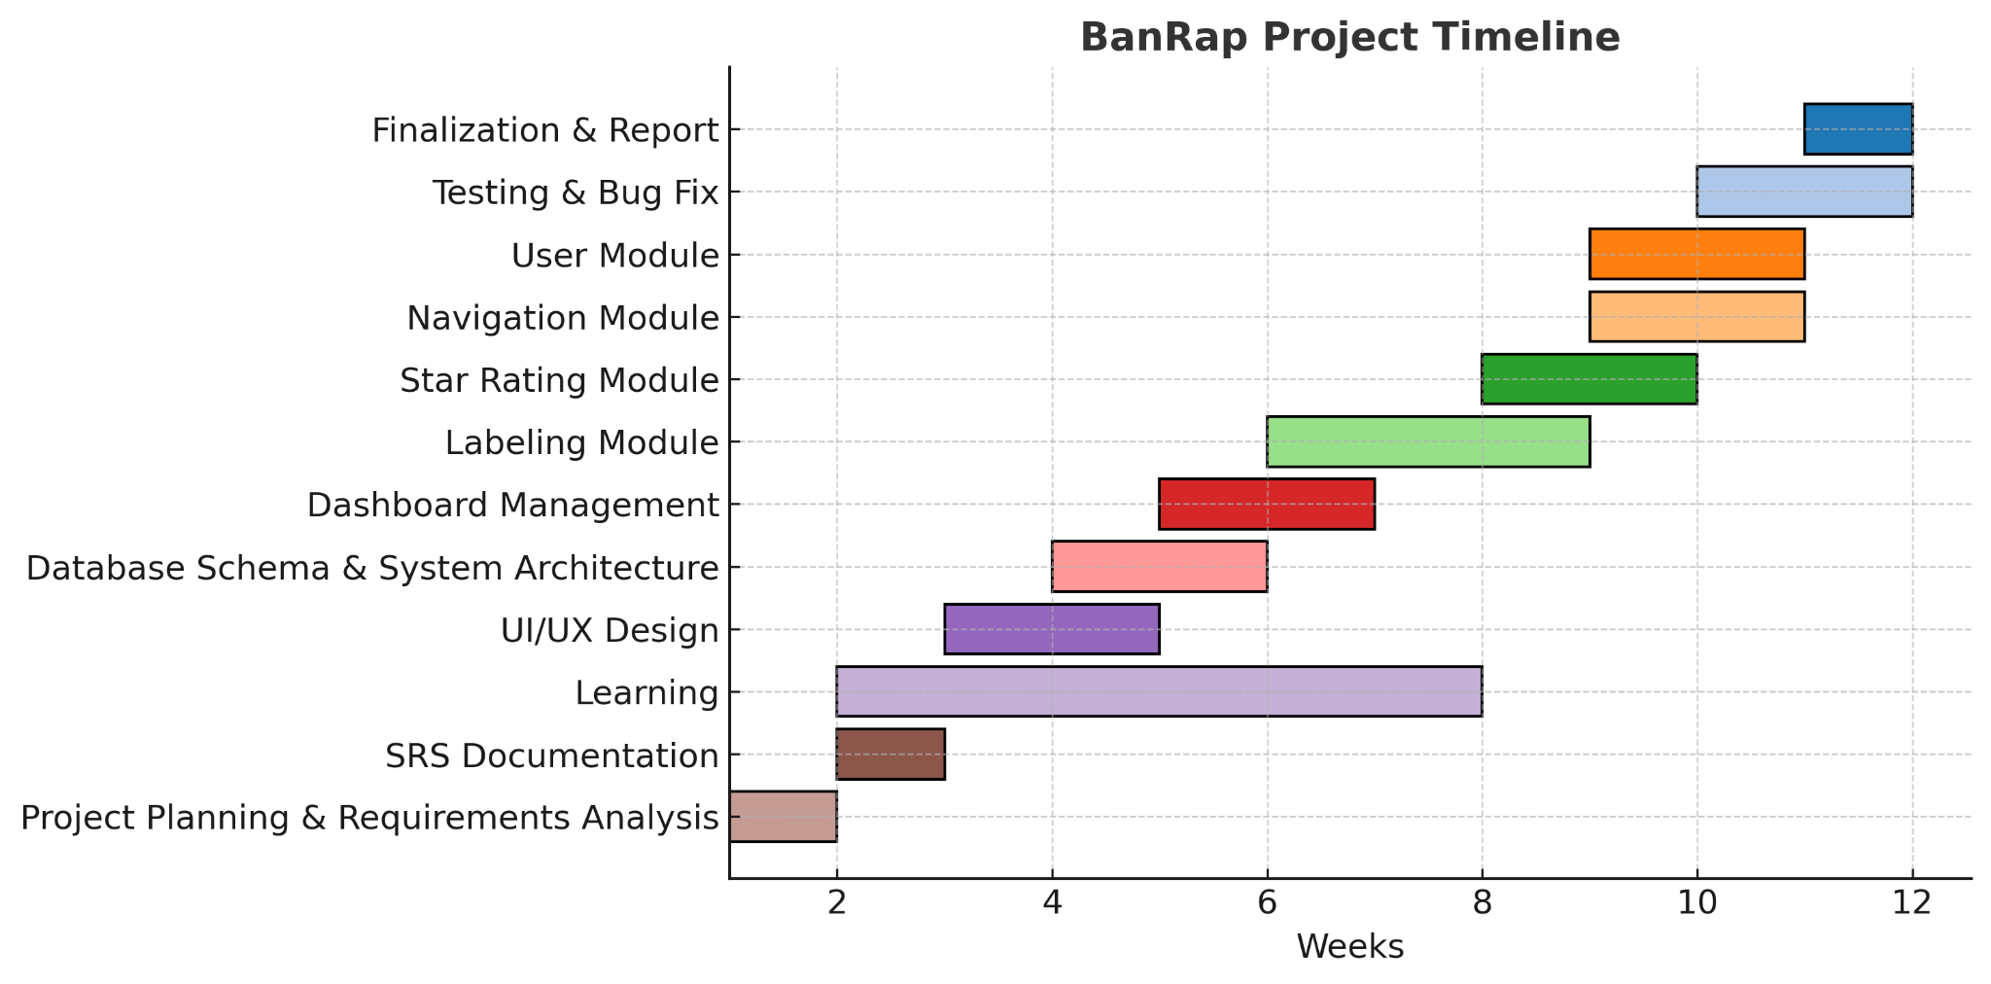

Languages or Tools to be used:
HTML, CSS, JAVASCRIPT, React, NodeJS/ExpressJS, PostgreSQL, PostGIS, Git/Github

Supervisor’s Name: Dr. Ahmedul Kabir
Signature of the supervisor:_________________________
Date: 06-11-2025

Before the Midterm Presentation 1:
I confirm that the progress is satisfactory and I am forwarding it for midterm presentation.
Signature of the supervisor:_________________________
Date: ________________________

Proposal Presentation Feedback (if any) :

Midterm 1 Presentation Feedback (if any) :

Midterm 2 Presentation Feedback (if any) :

